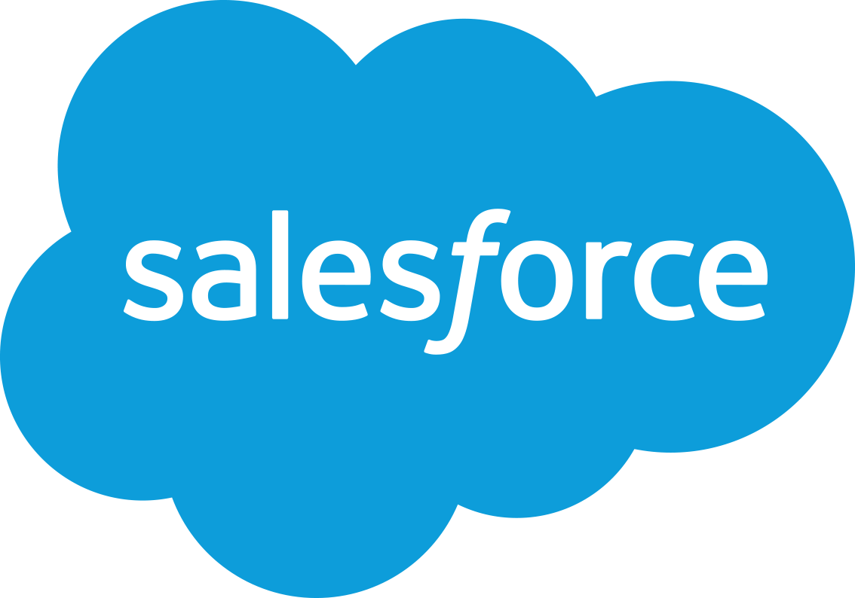

July 23, 2024

Dear Partner:   
  
Enclosed please find Salesforce content that can be used to support and augment your response to the Export Import Bank of the United States (EXIM) Task Order for Salesforce Licenses and CRM Services RFP. Throughout this document, we have referred to the customer as **‘EXIM’**.

Please note the following on how to use our content:

* Some of this content may change based on the customer’s response to solicitation questions or if additional amendments are released. If so, Salesforce will provide you with edited or additional content and the details of any changes that were made.
* Our content is not a complete response. You will need to review and incorporate this content into your response where applicable. Some responses to the customer’s requirements may also need additional input from you based on your provided services or solution. In this case, we have clearly marked throughout the document “**Note to Partner**” or “**Partner to Respond**” where you will need to either answer the entire requirement, or add content to the Salesforce response to complete the answer to a requirement.
* Some of our responses to specific RFx requirements include URL links offering more details. Since many customers may not allow linked content to be included in their evaluations, you may elect to incorporate some of that linked content into your final response for a particular RFx requirement.
* The content within this document is deemed ‘Private & Confidential’ and its intended purpose is to address the needs and requirements of EXIMin the context of this RFP**.** It is strictly forbidden to share any part of this message with any other third party, without a written consent of Salesforce.
* Our response includes Salesforce’s exceptions/assumptions to some of the customer’s Terms and Conditions outlined in the solicitation. These are areas that affect the delivery of Salesforce’s PaaS/SaaS services and where we may not fully meet a requirement. As the prime contractor, submitting the response to the solicitation, it is your responsibility to review these and incorporate them in your response where required.
* The obligations in the agreement between you and Salesforce, and/or its authorized Salesforce reseller, remain applicable. For the avoidance of doubt and to the extent you are an authorized Salesforce reseller, this includes any obligation in that agreement to make the Salesforce Terms of Use (or terms that are not materially different than or less protective of Salesforce than the Salesforce Terms of Use) as well as any applicable product specific terms, product terms or quote special terms part of your response to the EXIM Task Order for Salesforce Licenses and CRM Services RFP. Public procurement rules may prohibit you from introducing such terms at a later stage of the tender process.

**Disclaimer**

# 

**Note to Partner**: Please note the following disclaimer regarding the use of our provided content: This is intended to be cut and pasted into your RFx response. It is our disclaimer to you and to the customer.

***Salesforce is an innovative cloud services provider with evolving technology. Salesforce has made a good faith effort to provide you with responses to your request that are accurate as of the date of the response and within our knowledge. Because Salesforce procedures and policies change from time to time, and Salesforce continues to innovate by providing each customer multiple major release upgrades each year, we cannot guarantee that the answers to your request will remain the same over time. The rights and responsibilities of the parties with regard to your purchase and/or use of Salesforce’s online software services and/or Salesforce’s performance of professional services shall be set forth solely in the applicable agreement(s) executed by Salesforce, including its provision that any purchases thereunder are not contingent on the delivery of any future functionality or features, or dependent on any oral or written public comments made by Salesforce regarding future functionality or features. The responses herein shall not be part of a final contract. All information provided herein is deemed Salesforce Confidential Information and subject to the confidentiality terms contained in the agreements between you and Salesforce, and/or its authorized Salesforce reseller, and shall be exempt from disclosure to the maximum extent permitted by applicable law.***

***This document is provided for informational purposes only. It represents AWS’s current product offerings and practices as of the date of issue of this document and is subject to change. Customers are responsible for making their own independent assessment of the information in this document and any use of AWS’s products or services. This document does not create any warranties, representations, contractual commitments, conditions or assurances from AWS, its affiliates, suppliers or licensors. The responsibilities and liabilities of AWS to its customers are controlled by AWS agreements, and this document is not part of, nor does it modify, any agreement between AWS and its customers. For current prices for AWS services, please refer to the AWS website at*** [***www.aws.amazon.com***](http://www.aws.amazon.com)***.***

Table of Contents

**Assumptions & Exceptions 3**

**Executive Summary 9**

**Solution Overview 10**

Links to Salesforce Product Overviews 10

**Response to RFx Requirements 14**

**Salesforce Company Overview 24**

Recognition for Leadership in the Cloud 25

**The Salesforce Advantage 27**

API-First Approach: Open API and Seamless Integration 28

Trusted Platform with Security First Infrastructure 28

Move with Speed 29

Intuitive and Easy to Use 29

Lower TCO and a Dramatic Return on Investment (ROI) 30

# Assumptions & Exceptions

**Note to Partner:** When responding to the RFx, Salesforce has made the following assumptions and exceptions regarding our response.

|  |  |
| --- | --- |
| **RFx Reference** | **Exception or Assumption** |
| RFP B.8.1.1 SECURITY AND CLEARANCE REQUIREMENTS  As may be determined applicable, the contractor shall ensure that its personnel and subcontractors obtain and maintain the required security clearances / approvals needed to perform award and/or orders and assignment(s) or able to obtain additional security requirements needed for award and/or any specific order. | **Exception**  Salesforce is not providing assigned personnel to EXIM's solution implementation project. We believe this only applies to the project personnel that are performing the solution implementation services and not Salesforce, the Cloud Service Provider’s personnel that are hosting the solution.    All Salesforce employees are subject to a background check at time of hire.    Salesforce engages the services of a background screening vendor to conduct background checks on employees at the time of hire in the U.S. The scope of these checks is subject to local laws in the jurisdictions in which the employee is hired and includes:  • Address check: using the applicant’s social security, all residential addresses for the past 7 years are verified  • Criminal background check: state, federal, and national searches are performed to identify felony and misdemeanor convictions within the last 7 years  • Global sanctions and enforcement check  • Federal debarment check  • Healthcare sanctions check  • Education verification  • Employment history: queries up to three of the applicant’s most recent places of employment in the past 7 years  To protect against access through the application, Salesforce employees don't have access at the application level for any customers, unless the customer grants access through the "login as" feature.    Salesforce can provide contractual assurance to its customers that the data hosted in the Salesforce Services will be kept confidential and not accessed by Salesforce employees except as necessary to provide the services.    Permitted access to the production environment infrastructure is restricted to a very limited number of full-time Salesforce employees required to manage the service. These Salesforce employees do not have login access to customer's instances (org), and because of Salesforce’s multi-tenant infrastructure, they do not see customer data in an assembled manner. |
| RFP Confidentiality and Non-Disclosure Agreement (NDA)  The contractor may have to access to proprietary information of commercial entities or other 3rd  parties or the government and WILL be required to sign Non-Disclosure Agreements (NDA) and  Conflict of Interest (COI) statements as a condition of access to such proprietary information. An  NDA may be required of the contractor, executed by an officer of the contractor, and by each of  contractor’s personnel and subcontractor | **Exception**  Our interpretation is that this applies only to the System Integration personnel (its employees and subcontractors) that will directly perform the solution implementation services for EXIM, but not Salesforce, the Cloud Service Provider’s personnel.  To protect against access through the application, Salesforce employees don't have access at the application level for any customers, unless the customer grants access through the "login as" feature.  Salesforce’s personnel, as a condition of their employment, are required to sign a Confidentiality Agreement.  Confidentiality, Reliability and Limitation of Access. SFDC shall ensure that its personnel engaged in the Processing of Personal Data are informed of the confidential nature of the Personal Data, have received appropriate training on their responsibilities and have executed written confidentiality agreements. SFDC shall   * (i) ensure that such confidentiality obligations survive the termination of the personnel engagement; * (ii) take commercially reasonable steps to ensure the reliability of any SFDC personnel engaged in the Processing of Personal Data; and * (iii) ensure that SFDC’s access to Personal Data is limited to those personnel performing Services in accordance with the Agreement, any applicable Order Form(s) and Documentation.   For additional details please see: <https://www.salesforce.com/content/dam/web/en_us/www/documents/legal/Agreements/data-processing-addendum.pdf>  Salesforce can provide contractual assurance to its customers that the data hosted in the Salesforce services will be kept confidential and not accessed by Salesforce employees except as necessary to run the services.  Permitted access to the production environment infrastructure is restricted to a very limited number of full-time Salesforce employees required to manage the service. These Salesforce employees do not have login access to customer's instances (org), and because of Salesforce’s multi-tenant infrastructure, they do not see customer data in an assembled manner.  In addition, the Salesforce end user licensing agreement includes a confidentiality clause. Salesforce will access EXIM’s org only with prior approval from EXIM and subject to the confidentiality provisions of the licensing agreement.  We believe that the confidentiality language that is incorporated as part of the overall cloud SaaS/PaaS subscription agreement together with the restricted access to the data (except under narrow circumstances and with permission of the customer) and the confidentiality provisions signed by employees as a condition of their employment will meet this requirement. |
| RFP Section 508 – Compliance and Accessibility Requirements  The Contractor shall incorporate the 508-compliance and accessibility features into work products to facilitate any final accessibility adjustments to PDFs and to increase the efficiency of the process. PDFs of all sections shall be tested in the Adobe Acrobat Accessibility Checker and then checked manually. Some items cannot be verified with a manual check. For example, the checker might confirm reading and tab order exist, but they may not flow in a logical order. Data tables shall meet Section 508 standards for accessibility. Column and row headers must be identified. ID and scope should be used for more complex tables. | **Exception**  **Note to Partner: You will need to meet this requirement based on how you configure/customize the solution for EXIM as Salesforce SaaS/PaaS products are not 100% compliant out of the box.**  Accessibility  Salesforce is committed to providing on-demand enterprise applications accessible to all individuals. This includes users working with assistive technology, such as speech recognition software and screen readers. To help meet our goal of accessible design, Salesforce follows the internationally recognized best practices in Section 508 of the Rehabilitation Act and the Web Content Accessibility Guidelines (WCAG) 2.1 Level AA.    Salesforce introduced the Lightning User Experience, which brings a re-imagined user interface that is modern, efficient, and highly accessible. The Lightning Experience is engineered with Accessible Rich Internet Application (ARIA) features built in that help assistive technology users have the best possible experience with Salesforce. We provide software releases three times a year, ensuring that our customers can easily take advantage of the accessibility features introduced in each release.    The Salesforce Accessibility Conformance Report (ACR) (<https://www.salesforce.com/company/legal/508_accessibility/>) serves as a guide in evaluating conformance to Section 508 of the Rehabilitation Act and WCAG within Salesforce Lightning Experience UI. The accessibility features available within Salesforce applications are dependent on the application UI configuration and Lightning component usage. For this reason, adherence to accessibility requirements should be evaluated throughout the design and final testing of the Salesforce application and not merely on a specific ACR. However, any ACR referenced herein, or anywhere else on Salesforce’s website, or otherwise publicly available, shall not be construed to be included in any contract, either explicitly or implicitly, in whole or in part, absent Salesforce’s express acknowledgment through language in the contract itself that such report or its substantive equivalent is included.    The ACRs are encompassing of the features and functions of Salesforce products and provide an explanation of supporting features. Salesforce supports customers and partners by making itself available to review these ACRs and our product features. For further details: [https://help.salesforce.com/articleView?id=accessibility_contact.htm&amp;type=5](https://help.salesforce.com/articleView?id=accessibility_contact.htm&type=5).    Copies of ACRs are available on the Salesforce website at: <https://www.salesforce.com/company/legal/508_accessibility.jsp>. As new or additional ACRs become available, they will be posted to the Salesforce website.    Additional accessibility details can be found at: [https://help.salesforce.com/articleView?id=accessibility_overview.htm&amp;type=5](https://help.salesforce.com/articleView?id=accessibility_overview.htm&type=5) and <https://www.lightningdesignsystem.com/accessibility/overview/>.    Below we have highlighted two customer use case examples of accessible solutions deployed on the Salesforce Platform:   * *Bosma Enterprises - VisionForce:* As both a $50 million medical supply company and a not-for-profit provider of services for the blind and visually impaired, Bosma Enterprises operates in a unique space that requires a highly customized CRM and IT architecture. Many of the software vendors they evaluated were unable to conceive a single system that could track an individual’s progress through a medical rehabilitation program and also manage warehouse inventory and purchase orders. From the warehouse floor to the executive boardroom, Bosma Enterprises is run by blind and visually impaired workers, and today, every one of them logs into Salesforce to do his or her job. The 360-degree solution, which Bosma calls "VisionForce," is an integrated end-to-end business platform built on the Salesforce Platform. This new tool helps Bosma operate more efficiently and effectively to meet its mission of creating opportunities for people who are blind or visually impaired. In Bosma’s rehabilitation centers, the newly blind are given the tools to live their lives to the fullest, and with Salesforce, they continue that journey in the workplace. View Bosma’s Customer Success Story video here: <https://www.youtube.com/watch?v=b52zg_BNxIs>. * *Veterans Workshop:* Veterans Workshop is a veteran operated organization with the mission to help fellow disabled American Veterans get training and then get a job. The Veterans Workshop offers training in a whole host of different disciplines such as teaching blind veterans how to make phone calls for deaf veterans; teaching deaf veterans how to manage a website into 508 compliance; teaching technical support and cyber security, and more. Hear how a Marine Veteran and Certified Salesforce Administrator is making an impact in the lives of Veterans with disabilities. View Veteran's Workshop Success Story video here: <https://www.youtube.com/watch?v=m8CrsM5qLCc.> |
| RFP (b) The Contractor agrees, in the performance of this contract, to keep all information contained in source documents or other media furnished by the Government in the strictest confidence. The Contractor also agrees not to publish or otherwise divulge such information in whole or in part in any manner or form, or to authorize or permit others to do so, taking such reasonable measures as are necessary to restrict access to such information while in the Contractor's possession, to those employees needing such information to perform the work provided herein, i.e., on a "need to know" basis. The Contractor agrees to immediately notify in writing, the Contracting Officer, named herein, in the event that the Contractor determines or has reason to suspect a breach of this requirement. | **Exception**  If negotiated into a final contract, and for the Salesforce Government Cloud Plus only, Salesforce will without undue delay notify Customer in the event Salesforce becomes aware of a confirmed unauthorized disclosure of Customer Data in the Salesforce Services caused by Salesforce or its contractors. Notification may include phone contact by Salesforce support, email to customer's administrator and Security Contact (if submitted by customer), reporting to USCERT and DIBnet,and public posting on trust.salesforce.com. If the customer maintains an email address for a Security Contact in the Service then Salesforce will notify such Security Contact within **24 hours** of Salesforce becoming aware of such an unauthorized disclosure. Customer is responsible for maintaining the accuracy and currency of the Security Contact information.  Salesforce maintains an Incident Response Plan and has an established Security Incident Response Process. During a security incident, the process guides Salesforce personnel in management, communication, and resolution activities. Government customers can report security incidents related to their Salesforce products and offerings via security_gov@salesforce.com. Salesforce will respond in accordance with the incident response process described above.  Our incident response plan/process was created in accordance with FedRAMP and DoD IL4 control requirements which include incident response requirements derived from NIST SP 800-53, CNSSI 1253, NIST SP 800-61, and the FedRAMP Incident Communications Procedure. |

# Executive Summary

Salesforce appreciates the opportunity to respond and looks forward to the opportunity to continue a strategic partnership focused on pursuing innovation, superior service delivery, and mutual growth over the next five years.

Salesforce proposes the renewal of your current SaaS platform that creates a centralized, user-friendly customer relationship management tool accessible throughout the Office of Small Business within EXIM Bank. The platform currently supports over 150 individuals in allowing continued collaboration between EXIM Bank, their constituents and external partners.

Since 2015, Salesforce has supported EXIM Bank and we believe in continued innovation and partnership with a trusted vendor in order to support EXIM Bank’s mission.

We believe the benefits of working with Salesforce include operational efficiency, scalability, data security, and analytics and reporting. Salesforce enhances operational efficiency through streamlined processes and automation, optimizing resource allocation and reducing overhead costs. We provide scalable solutions that grow with EXIM Bank, accommodating future expansions and evolving business requirements. Importantly, we secure robust security features ensuring data integrity and compliance with industry regulations, safeguarding EXIM Bank’s sensitive information. Finally, we include powerful analytics and reporting capabilities providing actionable insights for informed decision-making and strategic planning.

This proposal aligns with EXIM Bank's strategic objectives of digital transformation and customer engagement. Salesforce's commitment to innovation and customer success ensures that the EXIM Bank remains at the forefront of technological advancement in the financial services sector. This roadmap will also include leveraging AI-driven analytics, enhancing mobile capabilities, and integrating emerging technologies to further elevate EXIM Bank’s operational efficiency.

Our current partnership represents a valuable investment in optimizing operational efficiency, ensuring data security, and supporting EXIM Bank’s mission of supporting American jobs by facilitating the export of U.S. goods and services. We are committed to supporting EXIM Bank's growth and success through our industry-leading solutions and dedicated customer service.

Thank you for your review and consideration.

# Solution Overview

**Note to Partner:** You will need to prepare a full solution overview for the customer. Salesforce has provided you with our proposed solution overview from the perspective of our technology based on our understanding of the customer’s requirements. You may use the below content to augment your response. [Here is a link to Salesforce’s solution diagram template](https://org62.my.salesforce.com/sfc/p/#000000000062/a/3y000000OoMm/RRug2cO.zbob.VJSNGcMkFZWsOd7ljxq5idNWHGofx8) which you can use to generate a tailored solution diagram:   
  
As detailed in the RFQ, EXIM has made a considerable investment in Salesforce technologies to meet the current and future needs of their business applications. The architecture diagram below helps to detail the current and future state of their Salesforce implementation.

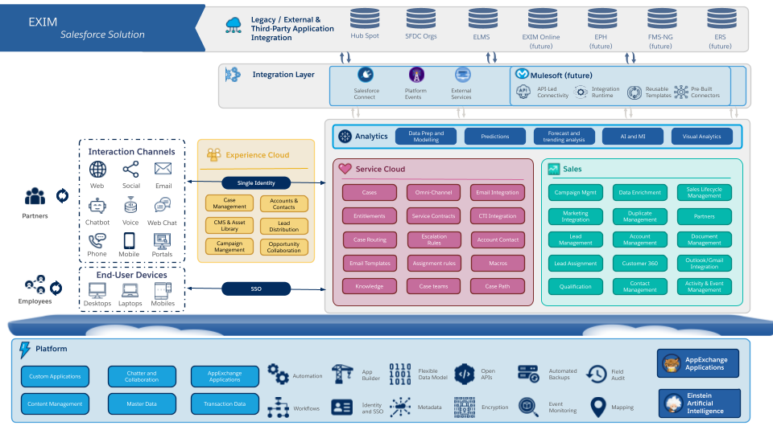

## Links to Salesforce Product Overviews

**Note to Partner:** Below is general documentation regarding Salesforce that you may weave into your response where applicable. We have also linked out to various attachments where you can pull additional information to use in your response.

[**Service Cloud Overview**](https://utopia-gps.demo.my.salesforce.com/sfc/p/MM0000001co1/a/MM00000001s9/k2X2.Htoy5QA5iUb9gDSlzGYMpoDtXye6Q6FJPbZ8QI)

**Note to Partner:** This links to a master Service Cloud Overview. It provides **all of the functions and capabilities of Service Cloud and other Salesforce products as additional licensing options (CRM Analytics [formerly Tableau CRM], Shield, Surveys, Experience Cloud [formerly Community Cloud], Salesforce Field Service, and other features such as mobile and integration** **capabilities)**. You may use this to tailor a solution overview specific to the customer’s needs.

Salesforce Service Cloud is the [industry-leading](https://www.gartner.com/doc/reprints?id=1-26J7Y9FQ&ct=210616&st=sb) customer relationship management (CRM) engagement center solution. Service Cloud will provide a 360-degree view of your customer including their cases and other customer relevant and related information and is a powerful tool to understand and address the needs of your customers.

For contact center and service agents, Service Cloud provides a single, intuitive console with the resources they need for EXIM to deliver superior customer experiences. With a world-class case management, tracking, escalation, assignment and entitlement engine, Service Cloud and the Service Cloud console enables EXIM’s service and support personnel to achieve more first contact resolutions, better maintain Service Level Agreements (SLAs), and increase customer satisfaction ratings at a fraction of the cost. EXIM can collect customer support requests from all traditional (email, phone), digital (Chat, Bots, SMS, WhatsApp, Facebook Messenger), and social (Twitter, Facebook, Instagram) channels, automate routine processes, route work using Omni Channel and Skills-Based Routing, and open up self-service knowledge bases, FAQs, and other help-related tools.

Salesforce’s powerful analytics engine using Tableau CRM can also deliver key performance metrics tailored to government organizations fast, without the need for code or IT resources.

With mobile and web capabilities through Experience Cloud, customers can self-service their needs. With a single location for self-service searching, answers from both corporate knowledge and community generated knowledge are returned. Unanswered questions can be seamlessly escalated through bots, automated processes, or through case creation pages.

Used in contact centers across all levels of government and in nearly every industry, Salesforce helps deliver great service with 45% faster deployments, 32% faster integrations, 30% increase in customer satisfaction, 27% increase in customer retention, and 36% decrease in IT costs. What’s more, with the power of the Salesforce [Platform](http://www.salesforce.com/platform/), Salesforce Service Cloud can be quickly and easily extended, customized, and adapted to any customer service challenge.

Additional key benefits include:

* Single solution with intake & resolution via multiple Channels (Phone, Email, Chat, Messaging, Social)
* Integration with back-office Systems and third-party applications through Mulesoft or other methods
* 360-degree view of all interactions with customers
* Better maintenance of service level agreements and entitlements management
* Increased customer satisfaction through self-service options and 360-degree view for agents
* Increased productivity and reduced support costs for agents and internal users
* Extensive metrics, reporting, and dashboard capability using Tableau CRM and standard Salesforce reporting and dashboards
* Easy to configure and scale on demand to changing needs and volumes
* Extensible with Salesforce Platform along with the ability to leverage the Salesforce [AppExchange](https://appexchange.salesforce.com/)

[**CRM Analytics (formerly Tableau CRM) Overview**](https://qbranch-sfdc.my.salesforce.com/sfc/p/5I000000mNA6/a/5I000000dnp3/vCbxhdX3kT5b2Nk.VnmCQTBjqIjtdB70boyMGTkxm_s)

**Note to Partner:** This links to a master CRM Analytics Overview. You may use any of this to tailor your response.

Salesforce core reports and dashboards deliver operational and performance metrics on data that lives solely in Salesforce and allows EXIM to easily create individual static reports and dashboards to gain real-time views of daily activity.

CRM Analytics is an analytics system based on our acclaimed Tableau product line - designed to analyze data not just from within Salesforce, but from across different sources, and be surfaced across EXIM. More importantly, it is designed to engage users every day by embedding analytics in business processes

CRM Analytics is mobile-ready, and you can immediately collaborate and share insights with team members right inside Salesforce. With CRM Analytics, it’s easy to integrate data from any of these sources, including external data such as SAP or Oracle data, mobile app data, or product sensor data.

CRM Analytics allows Public Sector entities to spot opportunities and predict outcomes with actionable insights and AI-driven analytics right in their workflow. CRM Analytics helps you see ahead, prioritize, and seize business opportunities. Focus on the information you need by customizing analytics to your business goals. Precise recommendations will help you anticipate opportunities you might have missed and lead you to better outcomes.

CRM Analytics ‘CRM Analytics’ empowers users to:

* ***Make the right decision every time:*** Work more efficiently, spot trends faster, predict outcomes, and get AI-based guidance on the best steps to take while you stay in the flow.
* ***Know exactly what to do next****:* Use the action framework to take action on a record like collaborating in Chatter, updating records, and sharing visualizations with the team.
* ***Fully part of Salesforce CRM****:* CRM Analytics is native to Salesforce so data can be seamlessly woven into every action and decision taken in Salesforce.
  + Native to Your CRM: Take action on insights in the context of the business process
  + AI-Built In: Automated discovery, predictions, and recommendations with no code required
  + Complete and Connected Platform: Easily build, customize, and extend your analytics and ML models in CRM and Tableau
  + Extreme Speed and Scale: Analyze billions of rows in seconds on the world’s #1 trusted cloud

Data is a strategic asset in all aspects of the public sector. With access to secure and governable data from multiple sources, public sector employees are able to discover new insights and better understand what's happening so they can act decisively.

[**Salesforce Government Cloud Plus Security White Paper**](https://www.salesforce.com/content/dam/web/en_us/www/documents/white-papers/sfc-22020-r-gov-cloud-whitepaper.pdf)

**Note to Partner:** This links to the Salesforce Government Cloud Plus white paper that you may reference for security purposes.

The Salesforce service has been designed to provide customers with 100% trusted privacy with the highest levels of performance, reliability and security. Depending on the State's final solution components and compliance requirements, Salesforce offers two options; Government Cloud and Government Cloud Plus, which are both dedicated instances of Salesforce Customer 360, composed of Salesforce’s industry-leading multi-tenant platform as a service (PaaS) and software as a service (SaaS) offerings. These environments are designed for mission impact and for use by U.S. government contractors, U.S. federal, state, and local government customers, and federally funded research and development centers.

**Government Cloud Plus - FedRAMP High.** Government Cloud Plus is authorized at the FedRAMP High Impact Level, the highest level of FedRAMP compliance, and a DoD Impact Level 4 (IL4) provisional authorization (PA).. Government Cloud Plus provides enhanced security and compliance controls to government contractors and organizations. This allows customers to use Salesforce for the most sensitive and unclassified data, giving contractors and government organizations a compliant and secure environment to operate their instance of the Salesforce Customer 360 platform. For more information on Salesforce Government Cloud Plus, please see the [Salesforce Government Cloud Plus whitepaper](https://c1.sfdcstatic.com/content/dam/web/en_us/www/documents/white-papers/government-cloud-plus-security-whitepaper.pdf) and the [Available Products and Features for Government Cloud Plus](https://help.salesforce.com/articleView?id=000321821&language=en_US&type=1&mode=1). 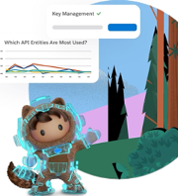

Enables government customers to lower overall cost, rapidly customize as needed, accelerate time to value, and scale the impact of their mission and charter. Partnering with AWS Gov Cloud further accelerates the ability to deliver the required security and compliance controls to protect the most sensitive, unclassified data. Through this partnership, the Government Cloud Plus inherits AWS GovCloud’s already JAB authorized compliance controls and opens up the ability for Government Cloud Plus customers to innovate at the speed of their customer's demands. [Learn more here.](https://secure2.sfdcstatic.com/assets/pdf/industries/government-cloud-wave-datasheet.pdf)

[**Security, Privacy, Architecture (SPARC) Documentation (All Products)**](https://trust.salesforce.com/en/trust-and-compliance-documentation/)

**Note to Partner:** Each of the Salesforce products have SPARCS (Security, Privacy, Architecture documents) for all the Services. Each SPARC will set out where the Service is hosted. This page on Trust.Salesforce.com provides links to the trust and compliance information for each Salesforce product.

Other Publicly Available Content (All Products)

**Note to Partner:** A lot of content and documentation is also available through Salesforce’s website. Here are a few examples of where you can search and find additional content to support your response:

[Trailhead](https://trailhead.salesforce.com/), [Trailblazer Community Help & Training Portal](https://help.salesforce.com/home), [Developer Community](https://developer.salesforce.com/)

[**Glossary of Salesforce Terms**](https://help.salesforce.com/articleView?id=glossary.htm&type=5)

**Note to Partner:** This links to Salesforce’s glossary of terms on the Salesforce website for your reference and if needed to describe anything more specifically to a customer.

# Response to RFx Requirements

### 

**Technical Response to RFQ**

|  |
| --- |
| 1.1 Performance Work Statement (PWS) |

**Note to Partner:** Partner to respond.

### 

|  |
| --- |
| 1.2 Quality Control Plan (QCP) / Quality Assurance Surveillance Plan (QASP) |

**Note to Partner:** Partner to respond.

|  |
| --- |
| 1.3 Key Personnel resumes with commitment letters |

**Note to Partner:** Partner to respond.

|  |
| --- |
| 1.4 Staffing / Transition Plan |

**Note to Partner:** Partner to respond.

|  |
| --- |
| 1.5 Technical Approach to successfully meeting deliverables |

**Note to Partner:** Partner to respond.

**Overarching Technical Objectives**

|  |
| --- |
| 4.1 OBJECTIVE AREA 1: SALESFORCE PRODUCT LICENSES  In reference to the pricing sheet, the contractor shall provide a catalog suite of Salesforce product licenses including, but not all inclusive, Sales and Service Cloud, Salesforce Platform, Experience Cloud, CRM Analytics, Marketing Cloud, MuleSoft, etc.). This will satisfy the ongoing, fluctuating requirements, updates, migrations, new products, etc.  4.2 OBJECTIVE AREA 2: LICENSES FOR PRODUCTS ON SALESFORCE’S APPEXCHANGE  In reference to the pricing sheet, the contractor shall provide licenses for Salesforce add-ons listed on Salesforce’s AppExchange that can enhance and expand Salesforce’s functionality. This includes D&B Connect for Salesforce, Copado DevOps Platform for Salesforce, Own for Salesforce, etc. This will satisfy the ongoing, fluctuating requirements, updates, migrations, new products, etc.  4.3 OBJECTIVE AREA 3: SALESFORCE IMPLEMENTATION AND SUPPORT SERVICES  The contractor shall provide Salesforce implementation and support services necessary to implement and manage the Salesforce platform and applications to meet EXIM’s requirements. These services include those outlined in the subsections below. The desired outcome is to deliver on the current  EXIM SOO for Salesforce Licenses and Services Page 9 of 14  objectives outlined in the Scope section above while also remaining flexible and responsive to new objectives and changing priorities.  Constraints  • Funding – EXIM has limited funding available so will be limited in the number of contract staff. This means contractor staff will likely need to perform more than one function for EXIM. See pricing sheet for optional CLINs added.  • Internal Controls – EXIM has to comply with government-wide and EXIM regulations and guidelines including on security and privacy. These controls, while important, can be an administrative burden and slow the process for developing and deploying new functionality.  • Reference B.8.1.1 SECURITY AND CLEARANCE REQUIREMENTS of solicitation which includes the below and applicable clauses and provisions,  o B.8.1.5 Contractor shall be responsible for properly protecting all information used, gathered, or developed as a result of this contract. …  o Sensitive Information Storage and Disclosure  o Protection of Information  o Security and Privacy  o Security Classification  o Data Rights  o Confidentiality and Non-Disclosure Agreement (NDA) |

**Note to Partner:** Partner to respond.

**Exception**

Our interpretation is that this applies only to the System Integration personnel (its employees and subcontractors) that will directly perform the solution implementation services for EXIM, but not Salesforce, the Cloud Service Provider’s personnel.

To protect against access through the application, Salesforce employees don't have access at the application level for any customers, unless the customer grants access through the "login as" feature.

Salesforce’s personnel, as a condition of their employment, are required to sign a Confidentiality Agreement.

Confidentiality, Reliability and Limitation of Access. SFDC shall ensure that its personnel engaged in the Processing of Personal Data are informed of the confidential nature of the Personal Data, have received appropriate training on their responsibilities and have executed written confidentiality agreements. SFDC shall

* (i) ensure that such confidentiality obligations survive the termination of the personnel engagement;
* (ii) take commercially reasonable steps to ensure the reliability of any SFDC personnel engaged in the Processing of Personal Data; and
* (iii) ensure that SFDC’s access to Personal Data is limited to those personnel performing Services in accordance with the Agreement, any applicable Order Form(s) and Documentation.

For additional details please see: <https://www.salesforce.com/content/dam/web/en_us/www/documents/legal/Agreements/data-processing-addendum.pdf>

Salesforce can provide contractual assurance to its customers that the data hosted in the Salesforce services will be kept confidential and not accessed by Salesforce employees except as necessary to run the services.

Permitted access to the production environment infrastructure is restricted to a very limited number of full-time Salesforce employees required to manage the service. These Salesforce employees do not have login access to customer's instances (org), and because of Salesforce’s multi-tenant infrastructure, they do not see customer data in an assembled manner.

In addition, the Salesforce end user licensing agreement includes a confidentiality clause. Salesforce will access EXIM’s org only with prior approval from EXIM and subject to the confidentiality provisions of the licensing agreement.

We believe that the confidentiality language that is incorporated as part of the overall cloud SaaS/PaaS subscription agreement together with the restricted access to the data (except under narrow circumstances and with permission of the customer) and the confidentiality provisions signed by employees as a condition of their employment will meet this requirement.

|  |
| --- |
| 4.3.1 User Administration and Support  The contractor shall provide day-to-day user support for EXIM’s users (90-120 internal (EXIM staff and contractor support), 50 external (EXIM partners)). This includes creating, modifying, and deactivating user accounts. It also includes assisting users with password resets and other login issues as well as troubleshooting user issues. |

**Note to Partner:** Partner to respond based on chosen solution configuration. Augment response with the following Salesforce information.

Premier Success Plan

The Premier Success Plan provides specialized guidance whether you have how-to questions, experience technical issues, need troubleshooting, or want to increase the value you get from Salesforce. Benefits include:

• 24/7 online and phone support by senior support analysts

• Expert coaching sessions

• Reviews of your platform health and business value

• Developer support

• Expert Assistance

• Specialized Guidance

• A discount on all Trailhead Academy courses and certifications

• Quicker response times than Standard Success. When critical issues arise, our skilled support engineers respond within one hour.

Expert Assistance

Expert coaching sessions are specialized engagements designed to help you get more value from Salesforce products. With Premier Success, you can attend webinars on a specific topic and watch coaching videos and then have an individual follow-up session to dive deeper. We also offer personalized sessions with Salesforce experts to help you overcome obstacles and drive long-term success. More than 200 options cover a range of needs and interests across Salesforce products.

To get real-time answers to your questions, Premier Success includes live Q&A sessions with Salesforce experts, addressing topics from adoption and how-tos to best practices. Specialized technical support is also available for admins and developers to troubleshoot custom code issues.

Specialized Guidance

To help ensure that you see continuing success with Salesforce, Premier Success includes personalized guidance and insights. Through periodic reviews and check-ins, we evaluate your platform health and value maturity. These technical and business reviews assess key areas of platform performance, prioritize areas for growth, and set and track progress against your targets with quantifiable success metrics.

In addition to contacting Support, customers can visit the Salesforce Help site and online user community at any time to find information or troubleshoot. We provide a variety of self-service tools to support users, including knowledge articles, training courses, videos, and other resources. Customers can also collaborate with other users to resolve their inquiries and find solutions.

|  |
| --- |
| 4.3.2 Security / Authorization to Operate (ATO) Activities  The contractor shall provide system security services in coordination with the Program Manager and EXIM’s Cybersecurity team. This includes:  • Creating new or update existing system documentation including but not limited to Salesforce system architecture diagram, a Privacy Impact Assessment, a System Security Plan, Salesforce Administrator Manual, Salesforce Configuration Documentation and others to support the approval and maintenance of the Authorization to Operate (ATO).  • Work with the Program Manager and Cybersecurity team to conduct reviews, provide artifacts, and other activities necessary to maintain the system’s Authorization to Operate (ATO) and related continuous monitoring.  • Implementing access controls, conducting user access reviews, conducting regular and ad-hoc system audits, and conducting impact analysis for new development projects. |

**Note to Partner:** Partner to respond based on chosen solution configuration. Augment response with the following Salesforce information.

Salesforce provides a flexible, configurable FedRAMP authorized solution that can support EXIM's business rules requirements, processes, and standards. Salesforce has a FedRAMP Agency Authority to Operate at the high impact level. To obtain compliance with FedRAMP, Salesforce conducted security assessment and authorization activities in accordance with FedRAMP guidance, NIST 800-37, and HHS guidance. To maintain compliance with FedRAMP, Salesforce conducts continuous monitoring, which includes ongoing technical vulnerability detection and remediation, remediation of open compliance related findings, and at least annual independent assessment of a selection of security controls.

As part of the implementation of EXIM's solution, a Salesforce certified implementation partner will review the applicability of the policies to be incorporated in the context of SaaS delivered by Salesforce. The Salesforce Platform is extensible, enabling EXIM with minimal effort to add additional custom fields and create automated workflows that are required to support EXIM's specific business processes.

Salesforce will maintain administrative, physical, and technical safeguards for protection of the security, confidentiality and integrity of Customer Data as described in the applicable Salesforce’s Services online documentation. Those safeguards will include, but will not be limited to, measures for preventing access, use, modification or disclosure of Customer Data by Salesforce personnel except to provide the Services and prevent or address service or technical problems, as compelled by law, or as permitted by a customer in writing.

|  |
| --- |
| 4.3.3 Requirements Analysis / Solution Design  The contractor shall provide requirement analysis services. This includes gathering, documenting, and analyzing requirements for all Salesforce enhancements and projects. The analysis must include impact analysis for all Salesforce user groups, to integrated systems, and to Salesforce security/privacy posture.  Additionally, the contractor shall design solutions to based off the requirements analysis to meet the business needs. Enhancements can vary from simple changes to existing processes to major projects to create new business processes, integration with other systems, etc. The contractor shall provide innovative solutions and leverage their knowledge of the Salesforce platform to ensure EXIM is effectively and efficiently using Salesforce.  The contractor shall work with the Program Manager and stakeholders to perform impact analysis and ensure the solution meets the requirements. The contractor shall design solutions that align with EXIM’s design guidelines, security/privacy guidelines, and industry best practices. The contractor shall design solutions that leverage existing Salesforce features and capabilities whenever possible, but the contactor shall also provide recommendations if needed on additional Salesforce features/products or third-party products necessary to effectively meet the requirements. |

**Note to Partner:** Partner to respond.

|  |
| --- |
| 4.3.4 Configuration and Development  The contractor shall provide Salesforce configuration and development services. Based on the requirements analysis and solution design, the contractor will configure Salesforce’s no-code features and/or develop custom code necessary to implement the solution design. These activities may require the implementation or updating of third-party apps (e.g. D&B Connect for Salesforce) that are installed, or may need to be installed, in EXIM’s Salesforce org. It may also require coordinating and collaborating with the technical teams for other applications to update existing integrations or implement new integrations. |

**Note to Partner:** Partner to respond based on chosen solution configuration. Augment response with the following Salesforce information.

Configuration vs. Customization

Salesforce offers EXIM a scalable, no-code, low-code development platform that will allow you to quickly develop and deploy a solution for EXIM. Salesforce’s low-code development platform promotes configuration over custom code, coupled with a market leading user experience for EXIM’s end users.

Salesforce's best practice is to have solutions that are 80 percent, or more, configuration based with the remaining functionality being customizations. In an ideal setting a solution would be 90 percent configuration. Regardless of the development approach, EXIM should aim to achieve this goal even if it means reengineering existing business processes.

It is important to note that not all vendor solutions define approaches to out of the box, configuration, and customization of their software the same way. Additionally, third party products are pre-built solutions powered and integrated with the Salesforce Einstein 1 Platform.

For example, EXIM may require custom fields for your solution. In order to meet this requirement, some vendors need to actually program “code or physically extend their RDBMS schema with non-programming “configuration tools"; and some vendors, like Salesforce, have pre-built “Administration Screens” where systems administrators or business analysts can go to quickly add new fields, pick list values, workflows, create users, add validation rules, etc. through a simple wizard-based point and click interface and system setup parameters. Salesforce considers these types of common system changes to be “administrative” changes rather than “configuration” or “programming”.

The Salesforce Einstein 1 Platform allows customers to build apps fast with just a few clicks, designed for desktop and mobile devices, all from a single canvas, including pre-built AppExchange solutions. To help IT deliver apps faster, the Salesforce Einstein 1 Platform offers a simple yet powerful set of declarative, point-and-click tools that anyone can use to achieve business goals at lightning speed. Without writing code, developers and business users alike can quickly and easily create custom apps on the Salesforce Einstein 1 Platform with complex business logic and beautiful user interfaces designed specific to every screen. Salesforce Lightning Builder tools allow EXIM to work in alignment with agile development methodologies as IT meets business demands faster.

If and where it may be needed, Developers can leverage the Apex programming language. Apex is an object-oriented, on-demand language. It is like Java, with similar syntax and notation, and is strongly-typed, compiled on demand, and fully integrated into the Platform. All of the application services come right out of the box, from a powerful workflow engine to API services, integration services, authentication, event log framework, analytics, and collaboration.

|  |
| --- |
| 4.3.5 Quality Assurance Testing  The contractor shall provide quality assurance testing services. This includes:  • Developing and documenting a test plan and business use cases that align with the nature and scope of the enhancement/functionality being tested and deployed.  • Executing test cases during Quality Assurance Testing (QAT) phase and document test results for both failure and success scenarios. The goal of QAT is to minimize the number of issues/defects discovered during User Acceptance Testing.  • Planning and coordinating User Acceptance Testing (UAT) with the Program Manager and business stakeholders and receiving formal sign-off.  • Coordinating with the technical teams for other systems when changes affect current integrations or when we are implementing new integrations. |

**Note to Partner:** Partner to respond based on chosen solution configuration. Augment response with the following Salesforce information.

It is important to note that the Salesforce platform, unlike traditional platforms, supports a declarative development methodology. This means that the typical development you would do in code, is done via a point and click, drag and drop interface. Quickly customize objects, fields, workflow, analytics, and more with no IT support or code. Since declarative development involves no code, no unit testing is required.

Functional testing and User Acceptance Testing are still recommended to ensure that the desired result has been produced through a Sandbox environment. Salesforce also supports code based development through Apex (based on Java) for more robust development as needed. We are firm believers in test-driven development and automated testing as a means to constantly assure quality in our releases. Automated testing allows for quick sanity checking and near real-time notification of regressions within our system.

To that end, the Salesforce platform enforces test class coverage of at least 75% before you can deploy Apex or package it for the AppExchange. In addition to the out of the box automation of unit tests, functional testing is commonly automated by customers using their choice of 3rd party tools like Selenium, AssureClick, Provar, HP QTP and others.

|  |
| --- |
| 4.3.6 Release Management  The contractor shall provide release management services. EXIM aims to conduct Salesforce releases every two weeks to ensure efficient turnaround on enhancement requests. The contractor shall work with the Program Manager to plan releases including what user stories will be included and ensuring all testing and approvals are received in advance. The contractor shall conduct the deployment and verification and work with the Program Manager and stakeholders on post-deployment verification testing. EXIM typically does releases on Thursday evenings from 8:00 p.m. to 10:00 p.m. Eastern Time to avoid interrupting users including those in EXIM’s West Coast offices. However, EXIM will occasionally do releases on other evenings or on the weekend depending on the scope of the release and to coordinate with other teams if it includes integrations. |

**Note to Partner:** Partner to respond based on chosen solution configuration. Augment response with the following Salesforce information.

Salesforce's position as an online service enables us to roll out all levels of improvement, from patch releases to major upgrades, that are largely transparent to the end users. Major software releases are typically rolled into production three times per year during off-hour maintenance windows. The Salesforce service will be generally available during major release upgrades. EXIM should expect to experience a disruption of up to five minutes during the time frame involved. Users will receive an error message informing them that the service is temporarily unavailable while we upgrade it to the latest release and will be prompted to log back in momentarily. After that time, users will be able to access the latest release.

Our development organization manages the source code in a code control system. Each product cycle includes design, development, quality assurance testing, and release. Releases are announced in advance and scheduled to provide the least impact on the Salesforce service.

The release process is managed by our site reliability. development, and QA teams to ensure the rollout goes smoothly. Technical operations and senior development personnel are on standby alert for any escalations. Content changes to the application code affecting application behavior are controlled manually, but the actual process is automated. For instance, a release engineer would remove some number of servers from the application pool, update them using the automated processes, manually spot-check them, and return them to the pool.

Bug fixes are rolled out as part of regular maintenance. Point releases are rolled out more frequently and are driven by a release manager. Patch or dot releases are typically limited to application code revisions, bug fixes, and minor functionality enhancements, which are performed online and are transparent to the users. E-releases are emergency releases that are performed online and are typically transparent to the users.

|  |
| --- |
| 4.3.7 Technical Documentation  The contractor shall update, create, and maintain technical documentation. The contractor shall create technical documentation for the security/ATO purpose outlined above, but also ensure we know how to re-build in case of disaster and to ensure any future EXIM staff or contractor working on Salesforce have clear descriptions of how Salesforce is configured and why. |

**Note to Partner:** Partner to respond based on chosen solution configuration. Augment response with the following Salesforce information.

Salesforce provides technical documentation on our Salesforce Developers site. Technical users can access information specific to the platforms APIs to support integration and development scenarios. Documentation is available in both online HTML and a printable PDF format. You can access our developer documentation at [http://developer.salesforce.com](http://developer.salesforce.com/).

Outside of the extensive resources on the developer site, Salesforce experts share tips, tools, and advice to help you optimize your investment in our technology. We provide resources such as e-books, reports, infographics, and demos to share guidance and best practices with customers by industry, business type, user role, and need. Find more information from our Trailblazer Community here: <https://success.salesforce.com/featuredGroups>.

|  |
| --- |
| 4.3.8 User Guides and User Training  The contractor shall create, update, and maintain user guides to support the different user groups. This includes specific user guides/tutorials for new features or processes in addition to the general user guides used for new user training and as reference for current users.  The contractor shall provide user training on new features or enhancements in collaboration with the Program Manager and business stakeholders. The contractor shall work with the stakeholders to determine what/if training is necessary when new features are released and what format that training should take.  The contractor shall provide recommendations and implement Salesforce In-App Guidance and other help features to support new user training and training on enhancements for existing users. EXIM currently does not utilize these features, but we plan to do so to help improve the user experience. |

**Note to Partner:** Partner to respond based on chosen solution configuration. Augment response with the following Salesforce information.

Salesforce Training and Learning Resources

Salesforce incorporates the following training and learning resources and best practices as part of the proposed subscription service as well as additional Salesforce instructor-led training that is available for an additional cost. There are also a variety of training resources accessible from within the Salesforce application.

Salesforce Help & Training Portal

Salesforce provides an intuitive help and training portal which brings together a rich set of resources that would give EXIM a centralized way to help solve problems quickly and easily. Salesforce also provides context-sensitive help icons throughout the application screens to make it easier for users to get unique help without searching. It is notable that we don’t provide large, offline help manuals. All our help is online, so we assure that online help is extremely thorough and effective for usability.

The Help site:

* Is fully customizable - You can personalize Help to meet your specific needs, customizing the gadget layout to show what is important to you
* Allows users to get the right answers, fast - Knowledgebase is more intelligent and comprehensive than ever (Auto Suggestion of Search Terms, Expanded Knowledge Repository [Help Docs, Solutions, FAQs, Training, Best Practices], and Refinement by Dimension)
* Provides chat - New engagement Channel gives customers the ability to chat with the Salesforce support team in real time
* Has easy case management - Opening and reviewing cases is easier than ever
* Makes your administrator’s life easier - Administrators gain insight with enhanced reporting on cases and organization information

In-App Guidance in Lightning Experience

In Lightning Experience, add prompts and walkthroughs to your app to share information, train, or onboard users. Write the content, select the target audience, and specify where it appears and for how long. You can add multiple items to the same page, but they don’t appear at the same time. By default, a user sees only one item per 24 hours, per app. Salesforce shows it again or cancels scheduled recurrences based on whether the user interacts with or ignores the prompt or walkthrough. Watch the video to learn how to navigate the In-App Guidance Setup page and builder; [Get Started with In-App Guidance in Lightning Experience](https://salesforce.vidyard.com/watch/EeyJabzZtNm67Fz6NzTFYM).

There are four types of In-App Guidance.

* Floating Prompt: Promote feature discovery and adoption with a short message that users can quickly read and dismiss. Place the prompt at one of nine different locations on a page.
* Targeted Prompt: Highlight a specific element on a page by pointing to the element with an arrow and graying out the rest of the page. Select the specific element that you want to target and position the prompt relative to the element.
* Docked Prompt: Drive feature adoption and help guide users through more complicated tasks. Embed images, videos, and step-by-step directions in a larger-sized prompt that stays available for users.
* Walkthrough: Provide guided, in-context training and onboarding on a single page or across multiple pages. Connect up to 10 floating, targeted, or docked prompts in a step-by-step, guided experience.

For more on details selecting the appropriate type of in-app guidance, best practices and considerations, please see the following Salesforce online help documentation, [https://help.salesforce.com/s/articleView?id=sf.customhelp_iag_types.htm&amp;type=5](https://help.salesforce.com/s/articleView?id=sf.customhelp_iag_types.htm&type=5).

Salesforce Printable Tip Sheets & User Guides

In addition to online help, Salesforce publishes printable documentation to help you be successful with Salesforce. These documents include tip sheets, user guides, and other resources that describe the features and capabilities of Salesforce. Link here for Getting Started information: <https://pages.mail.salesforce.com/gettingstarted/home/> and here to Salesforce’s online documentation: <https://help.salesforce.com/s/>

Trailhead: the Free, Fun Way to Learn Salesforce

Trailhead is accessible through the Search Documentation link in-app or through the Trailhead web page.

Everyone can learn Salesforce. Whether you are an admin, user or developer, there is a learning trail for you. Customers can sign up for a free Developer edition account and take advantage of the fun and free interactive learning curriculum provided at Salesforce Trailhead (<https://trailhead.salesforce.com/en/home>). Users can pick specific trails, modules or projects based on role (admin, user, etc.), experience level (beginner, intermediate, advanced), products (Service Cloud, Salesforce Platform, etc.) or topics (App Logic, CRM, Data Management, etc.) to learn new skills and absorb the information they need quickly.

* Trails - There are more than 170 trails to choose from that provide guided learning paths through modules and projects and help users cover the most ground in the shortest amount of time. They provide users a game plan for exploring new skills. Trails include Admin Beginner, Admin Intermediate, Developer Beginner, Develop Intermediate, CRM Essentials, Analytics, and more.
* Modules - There are nearly 655 modules that dive into specific topics. Modules introduce users to specific topics in bite-sized units. Users learn what a feature is, when it's helpful, and how to use it. Users can then test themselves with interactive challenges.
* Projects - There are more than 109 projects to choose from that provide users hands-on practice applying what they've learned. Projects give users hands-on practice with Salesforce technologies via step-by-step instructions and enable users to gain new skills and confidence working in Salesforce faster than they thought possible.
* Super Badges - Take the skills you've developed through Modules and Projects and apply them to real world, hands-on challenges.
* Trailhead Live - Live and on-demand videos from experts covering everything from certification preparation to building reports and dashboards, to coding best practices.

Developer Community

EXIM will also have access to the Developer Community, Salesforce's free developer program for the Salesforce Platform. The Developer Community website is a free community-based online portal for developers, where developers can learn, access key resources, and discuss a diverse set of topics anchored around the Salesforce Platform. These topics include Apex Code, Visualforce, Web service APIs, database topics, packaging and distribution of your applications, and much more.

The Salesforce Developer Community is comprised primarily of a technical body of developers and architects, system administrators and IT management.

The primary goal for the Developer Community is to promote community, learning and conversations. This is done through articles, the blogging community and its blogs, tech notes, sample code, providing a free Developer Edition account, together with discussion boards, RSS feeds, documentation, webinars, on-demand sessions, newsletters, event calendar and wikis.

Salesforce Premier Success Plan

With the Premier Success support plan, which includes support, training, and administration, EXIM will have unlimited access to our complete library of more than 100 online courses to build expertise in Salesforce products, drive value, and maximize ROI.

Customer Success Community

Customer Success offers many resources and tools to get started, including the Customer Resource Center ([success.salesforce.com](https://success.salesforce.com/)) with online Help, Learning Center and Communities, where you can tap into training videos, a knowledgebase, or reach out to other customers for best practices.

Ongoing success monitoring is a key part of Customer Success. Salesforce’s cloud computing model enables us to monitor usage data, to determine whether customers are getting the most from their subscription. We share this information with customers through Personal Account Reviews and Success Scorecards, along with actionable recommendations for improvement. Customer Success offers programs to help customers roll out new features or products, with training and adoption toolkits, to ensure our customers’ business benefit is always growing, and that they remain customers for life.

Additional Salesforce Training

Should EXIM desire instructor-led training in addition to online training and training that is included in the Premier Success Plan, for an additional cost, Salesforce offers a number of instructor-led courses tailored for user types. More information is provided at: <https://www.salesforce.com/services/learn/classes/#!page=1>.

Salesforce provides comprehensive training and certification options for every Salesforce user whether Administrator, Developer, Business Analyst, and others. Putting the right training plan in place for all Salesforce users is essential to a successful ongoing deployment. Salesforce Certification provides assurance that the team responsible for your Salesforce deployment is an expert in their field and up-to-date on the latest capabilities from Salesforce. As your team gets trained, certification is an important milestone to demonstrate readiness. And as you hire and contract with Salesforce Partners, be sure to look for Salesforce Certified Professionals to ensure that you are getting the right level of expertise, whether that is Certified Administrators, Developers, Solution Designers, or Technical Architects.

Training is available as:

* Self-paced, online courses as part of Premier Success Plan subscription
* Instructor-led classes delivered by Salesforce Certified Instructors at our facilities and through our Partners worldwide
* Private training classes held at your facilities, delivered by Salesforce Certified Instructors

For a complete list of courses, review the course catalog at [www.salesforce.com/training](https://www.salesforce.com/training). Learn more about the benefits of Salesforce Certification at [www.salesforce.com/certification](http://www.salesforce.com/certification).

|  |
| --- |
| 4.3.9 Salesforce Releases  The contractor shall conduct analysis of the release notes for Salesforce’s major releases. This includes identifying items that may have immediate impact to users or may impact development/administration activities. It also includes identifying changes or new features that EXIM could leverage to improve processes and the user experience. The contractor shall conduct testing in the release preview sandboxes and prepare any documentation/training needed if a change would impact users. |

**Note to Partner:** Partner to respond based on chosen solution configuration. Augment response with the following Salesforce information.

When maintenance is scheduled, Salesforce publishes the dates and times of the maintenance windows on trust.salesforce.com. Premier Alerts are sent via email when the maintenance windows are posted to trust.salesforce.com. In the event of planned maintenance that requires customer action in advance, such as updating network settings in preparation for additional login pools, Salesforce endeavors to communicate via email to system administrators of EXIM months prior to the maintenance. If emergency system maintenance is required, customers may be notified less than one week in advance.

There are two types of maintenance at Salesforce:

* System maintenance is for sustaining the security, availability, and performance of the infrastructure supporting Salesforce services.
* Release maintenance is for upgrading Salesforce services to the latest product version to deliver enhanced features and functionality. There are three different kinds of release maintenance: major releases, patch releases, and emergency releases.

Major release maintenance dates and times are posted on trust.salesforce.com approximately one year before the release date. Major release maintenance occurs three times per year.

Patch releases and emergency releases are used to deliver scheduled and ad hoc application fixes and are typically seamless to customers. Whenever possible, patches and emergency releases are deployed during off-peak hours and without downtime. You can see our preferred maintenance schedule at <https://help.salesforce.com/apex/HTViewSolution?id=000176208&language=en_US>.

Prior to every release, Salesforce provides resources to customers and employees to prepare for the release. As part of release planning, customers can try the next major release in a preview sandbox to test new features and their configurations. Customers can engage our support team if they find any issues or if there is a negative impact resulting from any changes or customizations.

A general outline of resource availability and timing is as follows:

* Four to six weeks prior to release. Customers get access to the upcoming major release in a test environment and are notified via email and our Trust site of the release maintenance dates and general downtime window. A release preview email is sent to customer admins that describes new features and enhancements, and a release preview is available on our corporate website.
* Two to three weeks prior to release. Release notes are made available three weeks prior to release. Sandbox (test) environments are upgraded two or three weeks prior.
* One week prior to release. Customers are notified via email and our Trust site of the exact downtime window for the upgrade.

|  |
| --- |
| 4.4 OBJECTIVE AREA 4: SALESFORCE CONTRACT SYSTEMS INTEGRATION  Work under this Objective Area 4 may occur at any time during the Base Year and during each Option Year. Work under this may be ordered several different times during the effective period of the contract  resulting from this Solicitation. The Government will further define the requirements for this task and ask for a detailed Level of Effort (LOE) to correspond with the further definition of this task, in the event the Government elects to order work under this task at a future date.  The Contractor shall work closely with the Office of Contracting Services (OCS), the Program Manager, and stakeholders such as IT business application teams (OCIO, OCTO, OSB, IDS), including personnel of other contractors, to design solutions that align with EXIM’s business needs and are consistent with the Contract Systems processes. The Contractor shall establish requirements definition of OCS current Contract systems process. The Contractor shall identify interconnected interfaces between ComprizonSuite, FPDS.gov, SAM.gov, shared network drive, and SharePoint.  4.4.1 Configuration and Development  The contractor shall provide Salesforce configuration and development services. Based on the requirements analysis and solution design from the Contract systems. The Contractor shall develop a OCS contract data system built on the Salesforce platform with integrations/connections to existing Contracting system to support EXIM. The Contractor shall provide EXIM business organizations with technical advice and support. The Contractor shall meet with EXIM stakeholders to collect, analyze, and refine high-level business needs and requirements. The Contractor shall identify opportunities to reduce total cost of ownership in operational application support areas such as appliances used to run, manage and maintain these applications.  The Contractor shall develop documentation (such as analysis and white papers) in support of the activities described in this SOO, to help educate and advise EXIM stakeholders, and upon request by EXIM, make presentations of same, to all levels of EXIM management.  4.4.2 User Guides and User Training  The contractor shall create, update, and maintain user guides to support the different user groups. This includes specific user guides/tutorials for new features or processes in addition to the general user guides used for new user training and as reference for current users.  The contractor shall provide user training on new features or enhancements in collaboration with the Program Manager and business stakeholders. The contractor shall work with the stakeholders to determine what/if training is necessary when new features are released and what format that training should take. |

**Note to Partner:** Partner to respond.

# Salesforce Company Overview

Salesforce is a global leader in customer relationship management software, delivering our cloud-based software through the internet as a service, bringing the public sector and customers together in the digital age. Founded in 1999, Salesforce enables organizations of every size to take advantage of powerful technologies—cloud, mobile, social, voice, and artificial intelligence—to connect to their customers in a whole new way.

The Salesforce Customer 360 for Public Sector is an integrated platform for public services that brings mission-critical capabilities to life - enabling relationship management, case management, team collaboration, integration, analytics and business intelligence, engagement and outreach and modern application development both within Salesforce and for third-parties. It gives decision-makers and teams a single, shared view of their customers so they can work together to build lasting, trusted relationships and deliver the personalized experiences their customers expect.

Salesforce is at the forefront of CRM innovation, consistently leading the industry. With nearly a decade of experience, we have been at the cutting edge of integrating Artificial Intelligence into CRM through our proprietary Salesforce Einstein technology. For government and public sector organizations, the application of AI presents a transformative opportunity to enhance operational efficiency and elevate the quality of service provided to the citizens. The Salesforce Einstein 1 Platform seamlessly incorporates AI across our comprehensive application suite, fostering unparalleled customer engagement, boosting staff productivity, and solidifying trust—all within the powerful synergy of CRM + AI + Data + Trust.

According to an [IDC study](https://www.salesforce.com/news/stories/idc-salesforce-economy-ai/), Salesforce and its partner ecosystem, fueled by the new wave of generative AI, will create a net gain between 2022 and 2028 of more than $2 trillion in business revenues and 11.6 million jobs. The study also identified the factors driving adoption of AI – led by improving productivity – and the biggest barriers to adoption, including the talent gap, data governance and risk management, cost, and trustworthiness and bias.

With thousands of customers and an ecosystem that includes over 2.5 million developers as well as hundreds of certified partners, Salesforce demonstrates how trusted, agile cloud applications help public sector organizations build trust and deliver better digital services.

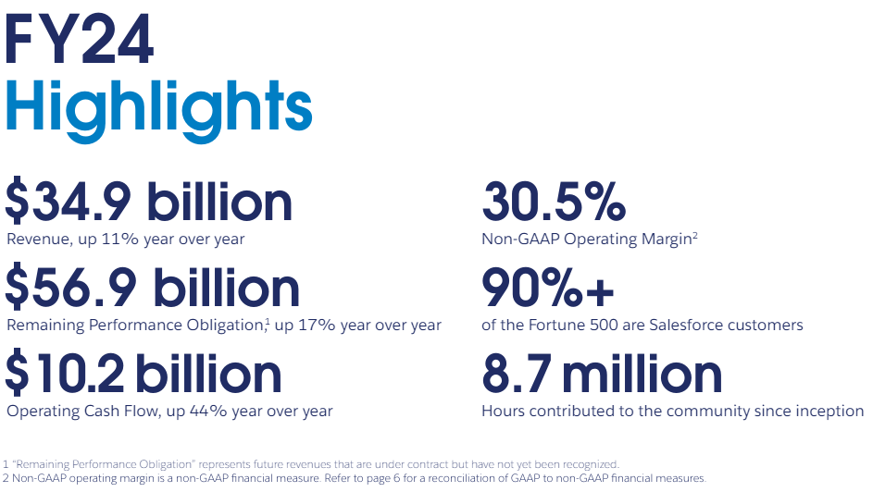

The FedRAMP-authorized Salesforce Government Cloud Plus - the world’s #1 enterprise cloud, built for government – gives stakeholders the mobile, self-service tools they need to connect data, process, and people while also reducing the risk, cost, and the complexity of traditional IT. Salesforce’s trusted Government Cloud Plus, delivered in an isolated infrastructure to meet Government Certification requirements, accelerates government transformation to rapidly and securely deploy solutions with a multi-tenant cloud infrastructure that meets all security and compliance requirements.

Salesforce is committed to a set of core values - trust, customer success, innovation, equality of every human being, and sustainability. For more information, please visit [www.salesforce.com/government](https://www.salesforce.com/government).

### Recognition for Leadership in the Cloud

Salesforce has received multiple awards and recognition for its expertise and leadership in the cloud. From Salesforce’s beginnings 25 years ago, their 150,000+ customers have responded to their cloud computing offerings with overwhelming enthusiasm. Such success has propelled Salesforce to be #1 in Enterprise Cloud Computing and #1 in CRM according to International Data Corporation (IDC). Salesforce also ranks as the Leader in the Gartner Magic Quadrants for “[Sales Force Automation](https://www.gartner.com/doc/reprints?id=1-2EQZGH5P&ct=230818&st=sb)” (SaaS), "[CRM Customer Engagement Center](https://www.gartner.com/doc/reprints?id=1-2F27UOGK&ct=230921&st=sb)", “[Enterprise Low-Code Application](https://www.gartner.com/doc/reprints?id=1-2F9JOOEX&ct=231010&st=sb)” and “[Multichannel Marketing Hubs](https://www.gartner.com/doc/reprints?id=1-2F5CG6B5&ct=230929&st=sb)”. In addition to the recognition from leading Industry Analysts, Forbes Magazine named Salesforce “Innovator of the Decade” and has named Salesforce one of the World’s Most Innovative Companies nine years in a row.

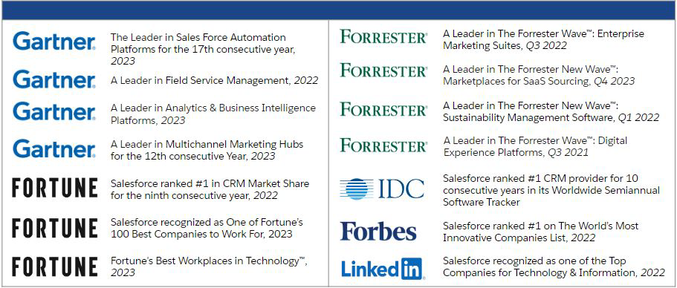

*The Magic Quadrant Gartner reports reflected in this graphic are available upon request from Salesforce. To access these reports, please go to:* [*https://www.salesforce.com/company/recognition/analyst-reports/*](https://www.salesforce.com/company/recognition/analyst-reports/)*.*

Rated #1 by IDC, Gartner, and Forrester, the Salesforce Platform has been designed to provide customers with high levels of performance, reliability, and security. Salesforce built and maintains a multi-tenant application architecture that has been designed to enable the service to scale reliably, and cost-effectively to accommodate millions of users. EXIM will not need to maintain any hardware or software. The Salesforce cloud based architecture will allow EXIM to deploy the proposed solution.

Salesforce is a publicly owned US corporation (CRM on the NYSE). All of our financial records are publicly available at [this link](http://investor.salesforce.com/about-us/investor/overview/default.aspx.).

# The Salesforce Advantage

Salesforce offers EXIM one integrated Customer 360 Platform that delivers out of the box cloud services that allow you to quickly get started and configure solutions specific to your vision and requirements. Salesforce represents a real break from government infrastructures where legacy systems and applications predominate, as well as a turnaround in the ability to directly engage citizens in various information flows with governing bodies and government agencies. The key benefits you will experience with Salesforce solutions are as follows:

Salesforce offers a digital-first, secure, citizen engagement Einstein 1 Platform that unites teams, unifies data with a single, shared view of the citizen, allowing public sector organizations to modernize their CRM and focus on building and maintaining relationships with citizens.

Salesforce facilitates the delivery of personalized interactions across all channels in a connected service experience—web, email, phone—and enables teams to respond faster and increase productivity. It also provides organizations with an AI-powered platform that allows public sector organizations to modernize services and work more efficiently with a single, comprehensive platform.

By harnessing the power of artificial intelligence, organizations can streamline processes, automate tasks, and provide valuable insights to help organizations better serve their citizens.

One of the key features of the Einstein 1 Platform is its ability to analyze large amounts of data quickly and accurately. This allows public sector organizations to make data-driven decisions and improve the delivery of services to the public. Additionally, the platform can automate repetitive tasks, freeing up valuable time for EXIM’s employees to focus on more important and complex issues.

With the Einstein 1 Platform, connecting data across systems, apps, and devices creates a single source of truth and empowers EXIM to integrate disparate systems. This brings all your data together as a single source of truth to enable teams to work more effectively and enriches the citizen experience.

In the Public Sector we know trust is an important component of your mission and public sector organizations need trusted solutions to take on the challenges facing their communities. Salesforce is committed to safeguarding your information by continuously enhancing our applications, systems, and processes to address the evolving requirements and complexities of security.

Trusting generative AI with EXIM’s confidential information and your citizen data while balancing the benefits of generative AI is a challenge many organizations face. [The Einstein Trust Layer](https://help.salesforce.com/s/articleView?id=sf.generative_ai_trust_layer.htm&type=5) is a secure AI architecture, built into the Salesforce platform. It is a set of agreements, security technology, and data and privacy controls used to keep EXIM safe while you explore generative AI solutions.

The Einstein 1 Platform allows public sector organizations to modernize citizen services with CRM, AI, data and trust setting the stage for sustained achievement.

**Multitenant Model: API Driven, Rapid Scalability and Free Upgrades**

Salesforce is built on a unique, multitenant architecture: cloud services share a single common infrastructure, code base, and platform that is centrally managed—removing unneeded tasks from the process of delivering, managing and integrating software. Salesforce delivers configurable, scalable solutions all via the web. The following reasons highlight why multi-tenancy is a benefit for EXIM:

* Salesforce provides three complimentary, seamless, and automatic major release updates per year, which won’t impact EXIM’s workflows, integrations, reporting, or configurations. Maintenance and upgrades, including security patches and compliance driven updates, are pushed out to all organizations at the same time rather than to each individual tenant’s system. This reduces the amount of time your teams have to spend maintaining and protecting your data, since there are no multiple versions to support. Integrations, customizations, and configurations are updated automatically, allowing your IT resources to focus on innovation instead of managing many different version updates.
* Although centrally managed, the Einstein 1 Platform is fully configurable through clicks to meet your unique requirements. Our point-and-click, drag-and-drop tools make it easy for non-technical administrators to configure the solution. For more technical administrators and multifaceted customizations, you can utilize Apex code to build complex business logic into your application.
* Multi-tenant cloud platforms are highly scalable. Multi-tenancy gives applications elasticity. They can easily scale from one to tens of thousands of users from one program to the next without the need for additional hardware or software.
* Mobility is a native capability of the Einstein 1 Platform. The Salesforce Mobile App, compatible with iOS and Android, provides a seamless mobile experience with access to most application functions. It is a standard feature requiring no customization or third-party tools. Users can access Salesforce services configurations, customizations, settings, and data from anywhere. The app allows building and operating mobile and desktop apps on one platform, developing tailored mobile profiles, and automatically pushing configurations/customizations, eliminating the need for device sync.

## API-First Approach: Open API and Seamless Integration

Salesforce provides out-of-the-box APIs that enable organizations to both integrate our solution with existing third-party, custom, and legacy apps *and* write their own application services that integrate with our solutions.

* With the flexibility that the Salesforce platform provides, there are a range of integration options available from native Web Services support (APIs, outbound workflow, etc.) to import/export utilities to middleware integration via packaged connectors to toolkits for Java, .NET, and more.
* Driven by the API-first principle, apps can use open APIs based on industry standards such as REST and SOAP to add data from other systems. For more complex apps, developers can leverage the Apex programming language. Apex is an object-oriented, on-demand language, which enables developers to add business logic to most system events, including button clicks, related record updates, and Visualforce pages.

## 

## Trusted Platform with Security First Infrastructure

Salesforce maintains a comprehensive set of compliance certifications and attestations to validate our #1 value of Trust. These are listed on our Compliance Portal available here: <https://compliance.salesforce.com/en/documents>. These standards serve as independent evidence of the security measures in place, providing organizations with reassurance about the security of their data. By meeting these standards, Salesforce demonstrates its commitment to maintaining a secure environment for its users.

Salesforce uses a multi-layered approach to protect your data, constantly monitoring and improving our application, systems, and processes to meet the growing demands and challenges of security. In addition, independent audits confirm that our security and subject matter experts go far beyond what most customers would have been able to achieve on their own. This contributes to Salesforce’s ability to meet a number of compliance requirements, including:

* ***FedRAMP Authorized SaaS/PaaS at the Highest Level.*** Salesforce has invested in delivering a multi-tenant public cloud infrastructure specifically isolated for use by the U.S. government. Our cloud-based solutions, Software as a Service (SaaS) and Platform as a Service (PaaS), are FedRAMP certified at the High Impact level to provide EXIM with the assurance that your data is secure and private, with high levels of performance and reliability. Salesforce has also received a Provisional Authorization (PA) from Defense Information Systems Agency (DISA) at Impact Level 4 (IL4) and an attestation for compliance with NIST SP 800-171 from a FedRAMP approved third party auditor. A cloud-based application allows EXIM to minimize internal administration, while providing organizational agility, speed-to-value, and ease-of-use.

**Note to Partner:** Include the language below *only* if including AppExchange options (additionally, call out the specific AppExchange product you are proposing). Insert Government Cloud Plus or Government Cloud Plus Defense as indicated:

The Salesforce Government Cloud Plus FedRAMP information system and authorization boundary does not include the following solutions that are being proposed as additional licensing options should EXIM desire to acquire these additional products as part of its overall solution:

* **Insert ISV Name (Additional Licensing Option).** Insert ISV name holds its own FedRAMP Authority to Operate for its Software as a Service (SaaS) solution, consistent with the FedRAMP moderate baseline controls. Insert ISV name is an ISV application and is interoperable on the Salesforce Government Cloud Plus.
* **Insert ISV Name (Additional Licensing Option).** Insert ISV name is an ISV application built native on the Salesforce Lightning Platform, meaning it runs entirely within the Salesforce PaaS, and is interoperable on the Salesforce Government Cloud Plus.
* **AppExchange Solutions (Additional Licensing Options).** Some Salesforce AppExchange providershold their own FedRAMP Authority to Operate for its Software as a Service (SaaS) solution, consistent with the FedRAMP moderate baseline controls. AppExchange solutions are Independent Software Vendor (ISV) applications and are tested for interoperability on the Salesforce Government Cloud. There are also some AppExchange solutions that can hold their own FedRAMP Authority to Operate, consistent with the FedRAMP moderate baseline controls.

## Move with Speed

Salesforce offers out-of-the-box, no-code, low-code capabilities allowing organizations to rapidly configure solutions to modernize common business processes and operations. Organizations can reduce cost and dependency on legacy development technologies with high availability, flexibility, and capacity on demand. EXIM can streamline workflows, organize resulting data and information into personalized citizen experiences, and deliver services faster, such as:

* Streamline engagement without having to manually upload data, wait on communications to go out, answer data calls or stitch together a custom-built report instead of integrating third-party systems.
* Quickly collaborate with other users, subject matter experts, and partners that are critical in helping EXIM meet its mission.
* Digitize and standardize more touch points across programs, services, and activities, bringing it all together in a single, 360 degree view of your citizen.
* Meet citizens where they are with 24x7, self-service interfaces that enable EXIM’s employees to respond in real-time across a number of communications channels.
* Improve communication and collaboration within public sector entities. By providing a centralized platform for sharing information and coordinating efforts, the Einstein 1 Platform can help streamline workflows and improve overall efficiency.
* Automate repetitive tasks, freeing up valuable time for EXIM's employees to focus on more important and complex issues.
* Organize your data with Salesforce in order to take advantage of the AI trends by turning touch points into data points, standardizing formats, setting up governance models and bringing it all together in a 360-degree view. AI-generated recommendations are only as effective as the data that fuels them; the more information being analyzed, the more statistically significant AI’s findings will be.

## Intuitive and Easy to Use

EXIM’s users don’t have to be IT experts to build new customized apps, new ideas, or new innovations. Salesforce solutions are designed with low-code, no-code and are easily configurable with access to pre-built apps, and built-in training for users.

* The Einstein 1 Platform provides drag-and-drop features that will speed up and streamline your development process. To improve efficiency and achieve the highest value from your Salesforce investment, EXIM can easily configure the solution to best fit your user’s needs. Users can build complex flows, configure their user interface, or develop applications with just a few clicks vs. writing lines of code – to name just a few. The Einstein 1 Platform offers tools to make it possible to create both fast and easy configurations through clicks, as well as customizations to satisfy any requirement through code methodology.
* With the Salesforce AppExchange, EXIM will have access to 7,000+ prebuilt apps automatically integrated with Salesforce SaaS and PaaS solutions as well as access to a network of certified consultants that can assist you with your Salesforce implementation and provide a managed service. With just one click and a Salesforce account, EXIM can expand its initial investment by finding, testing, and deploying pre-integrated apps – you can extend the Einstein 1 Platform and tackle organization problems or quickly pivot as your needs change. For more information, visit <https://appexchange.salesforce.com/>.
* Trailhead is a gamified learning platform created by Salesforce where users access a variety of online courses and tutorials for free on topics such as Salesforce solutions, business skills, and technology. Users can tailor their learning to match individual goals and interests, get hands-on experience with interactive modules in demo or “sandbox” environments, and advance their skill levels based on their career paths. Users can also connect with other Trailblazers, mentors, and experts to share knowledge, ask questions, and collaborate on projects. This sense of community fosters continuous growth and development.

## Lower TCO and a Dramatic Return on Investment (ROI)

Salesforce AI-Powered Cloud Solutions can deliver clear customer and organizational benefits, with the largest benefit coming from employees and customers touch points (at 62%), such as customer service calls. The second largest benefit is improved overall customer experience (61%), and lowered costs to acquire, retain, or service customers (47%).

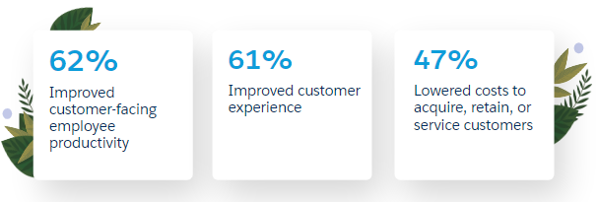

View the [IDC White Paper: The Salesforce AI Economy Forecast](https://www.salesforce.com/content/dam/web/en_us/www/documents/reports/idc-salesforce-economy-report.pdf) for more information and full details.

Salesforce gives public sector organizations tremendous value by enabling them to anticipate the significant savings they can achieve, as opposed to using the traditional cost model for enterprise software. Since all of our customers generally pay per subscriber for the Salesforce service over the life of the subscription contract, customers benefit from being able to fully anticipate these future costs. After all, they don't have to buy hardware or software upfront that they will only use later. Another key differentiator is the flexibility in cost models we can offer to account for peaks in usage. In addition, because Salesforce implements all updates on Salesforce servers, all Salesforce customers benefit immediately from new features and functionality on each release date.

Independent studies conducted by leading industry analysts such as Gartner, Forrester, and IDC (International Data Corporation) demonstrate the cost-effectiveness and high return-on-investment potential of the Salesforce platform. The IDC study published in October 2020 cited the following key business results:

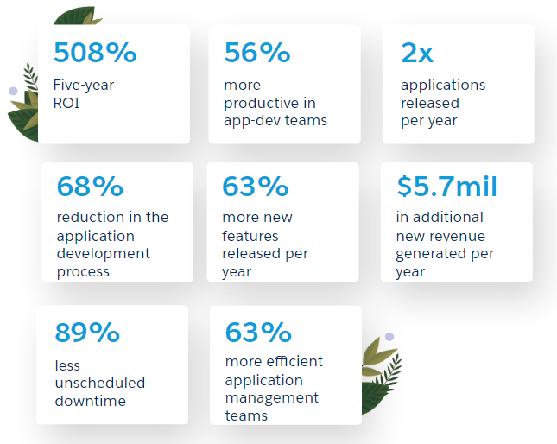

View the [IDC report](http://www.salesforce.com/au/form/pdf/idc-roi-study-2020/) for more information and full details.